MAGIC WITH A MESSAGE

Online Lecture Notes


By Jamie Doyle
Copyright 2004

Some lesson ideas previously used in earlier books by Jamie.

Magic With a Message
Jamie Doyle
Children’s Pastor at River Valley Church – Apple Valley, MN

According to Dariel Fitzkee in his book, The Trick Brain, all magical effects can be categorized into one (or more) of "nineteen basic effects." Here is how Mr. Fitzkee identified them in three divisions (in his own words):

Physical Accomplishments:
Productions | (Appearance, creation, multiplication) The production of a person or an object where nothing appeared before. Something is caused to come into view without apparent clue as to the source.
Vanish | (Disappearance, obliteration) The causing of something to pass from sight by apparently unnatural means
Transposition | (Change in location) Invisible change in location of a person or object from one place to another.
Transformation | (Change in appearance, character or identity) A person or an object changes identity, color, size, shape, character, etc.
Penetration | (One solid through another) The solid matter of one person or object or thing penetrates the solid matter of another person, object or thing.
Restoration | (Making the destroyed whole) The subject of the effect is wholly or partially destroyed and subsequently restored to its original condition.
Animation | (Movement imparted to the inanimate) An inanimate object is mysteriously endowed with movement.
Anti-Gravity | (Levitation and change in weight) The person or thing reacts contrary to the laws of gravity.
Attraction | (Mysterious adhesion) Causing someone or something to become endowed with a power resembling magnetism.
Sympathetic Reaction | (Sympathetic response) More than one unconnected person or objects react the same, as connected.
Invulnerability | (Injury proof) Demonstrations of resistance or proof against injury.
Physical Anomaly | (Contradictions, abnormalities, freaks) Exceptions or contradictions to normal/physical and physiological rules and reactions.
Mind Dominance:
Spectator Failure | (Magicians' challenge)  All tricks where a spectator is unable to accomplish some apparently simple objective, implying the intervention of some mysterious power of the magician.
Control | (Mind over the inanimate)  All effects where the mind of the performer seems to dominate, whether the subject be animate or inanimate.
Mentalism:
Identification | (Specific discovery) Discovery of an identity, regardless of the method of disclosure.
Thought Reading | (Mental perception, mind reading) Apparently reading the thoughts of another.
Thought Transmission | (Thought projection and transference) One person projects his thoughts to another
Prediction | (Foretelling the future) All tricks where the future is foretold.
Strange Perception | (Unusual perception, other than mind) All types of abnormal perception other than through mental communication.

I am not demanding that you consider each of these concepts, I am only making you aware of them. I have, however, found a way to place a Spiritual application to most of these concepts over the years. I suggest that you study and know the above concepts thoroughly. They will help you in determining which magical effect will most effectively teach your concept.

Gospel Magic/Object Lesson Worksheet

Theme (Subject) : _______________________________________

Theme Statement: Theme + Viewpoint = Result or Action to Take

Theme : _______________________________________________

+

Viewpoint:_______________________________________________
(What you think about it/what you want your kids to think about it/what the Bible says about it)

=

Result or Action to Take:_______________________________________________
(What you want your kids to know and/or do about it).

Sample: For the Torn and Restored Bible (A Restoration Trick)

Theme (Subject) : The Word of God will Last Forever

Theme Statement: Theme + Viewpoint = Result or Action to Take

Theme : The Bible…

+

Viewpoint: It’s God’s Word.
(Display strip of paper)

+

Viewpoint: People have tried to destroy it for years.
(Tear up the paper)

+

Viewpoint: The Bible says that Heaven and Earth will pass away… but not God’s Word.
(Fold the paper pieces and restore the paper)

=

Result or Action to Take: God’s Word will last forever, so put your faith and trust in it.
(Display the restored paper and hold it close to your heart).
God Already Knows

Scripture References:

Lesson Concept:
The teacher writes down a number prediction that he has a student hold… After having random numbers called out and addition and subtraction… the final result is the prediction written down earlier.

Needed:
- Envelope
- Paper
- Heavy Marking Pen
- Chalkboard and Chalk or Whiteboard and Markers.

Preparation:
On a piece of paper, write the number 1089 in very bold lettering. Fold the paper and seal it in an envelope. Mark on the envelope “I Already Know” and put it in full view of the class from the very beginning. Have the Chalkboard or Whiteboard ready and in full view of the class. On it, make a list down the left hand side:
- Number
- Reverse
- Subtract
- Reverse
- Add
- Answer

Presentation:
- This is a fun math trick that can be done anytime and literally anywhere. The great thing about this trick is that the end result will always be the number “1089”. Hold up the envelope and call attention to the message on the front. “I already know what number we are going to get at the end of this experiment… you are going to get to help me pick the numbers to get started.”

- Now, show the list on the board and explain that this will be our formula to get to the answer. Remind them that you already know what the answer is.

- Have a volunteer hold the envelope so that you cannot get it. For fun, I always try to take the envelope away… if the kid gives it up, I give him a hard time about it and it usually always gets a laugh.

- “Now for the first part of our formula… the Number. I need three volunteers to each think of a number between 1-9.” Have the three individuals call out three different numbers between 1-9. *This is very important: make sure each calls out a different number. If a volunteer calls out the same number as one of the other volunteers, remind them that it must be different. Write them in the order that they are called on the board so they form a three-digit-number. Let’s say the numbers are 9,7 and 2. Write them as: 972.

- Make sure you remind the kids that they were the ones who picked the numbers to begin with.

- “And now for the next part of our formula: Reverse. We need to reverse the order of the numbers.” Under the 972 that you have written, reverse the numbers so that it reads: 279. See the example below.

972
279

- Once this is done it’s time to subtract the bottom number from the top number:

972
-279
693

- Now, reverse the number again and write it under 693 and the next step would be to add these numbers together and you will get the final answer: (this matches your note inside of the envelope).

693
+396
1089

- Once you have your final answer, remind the kids once again that they had a part in choosing which numbers. But even though they chose the numbers, you already knew what the result would be. Have the volunteer with the envelope open it up and hold the note with the prediction so all can read it.

“Just like this prediction was accurate, God is more accurate in his knowledge of the future. He knows everything that has happened and He knows what’s going to happen. He knows all about you and He loves you too! Now, I knew what the end result would be because of a math trick that anyone could do if they know the secret. But, there are no secrets when it comes to God knowing all.”

The Bible Tear – Flash Restoration!

Scripture Referrnces:
Matthew 24:35 “Heaven and earth will pass away, but my words will never pass away”

Effect:
The performer displays a sheet of paper with a picture of a Bible on it. He proceeds to tear the sheet into four quite separate quarters. After the final tear and as soon as the pieces are brought together the entire packet of torn paper is flipped open and appear to have restored themselves to reveal the picture once again.

If you do a “Bible Tear” message or any torn and restored routine that is similar to a Chinese Laundry Ticket Trick, you may want to add this idea to make it a little more “Flashy”. The trick is a combination of ideas including the “Bible Tear”, “Climax Dollar Bill”, “Joel Bauer’s Flash Restoration Newspaper” and the “No Tear Restored Newspaper”. Just add your favorite “Bible Tear” Patter and you’re off!

Supplies Needed:
- 8.5 X11 opaque paper
- A process for printing or photocopying
- Rubber cement
- Small, thin craft magnets (the stronger – the better).

To Prepare:
Using a computer, design two identical pages with a picture of the Bible on it. I like to use a computer and print with a color printer. I like this method because of all the sharp-looking clipart available. Find a good picture of the Bible. If you cannot find a picture, use a large font in colors that will be appealing to your audience. A color printer will make your presentation look so much cleaner and professional. I have also used a photo copier in a pinch… just make sure the paper you use is opaque.

Fold one of the pages in the manner that you see in figures 1 – 7. This is your duplicate. Fold the original into four quarters. Make sure you reinforce the folds in both directions for easier tearing. On the backside of your duplicate glue a craft magnet to the center of each quadrant. (See Figure 8) These will hold all of the torn pieces together once the flash restoration occurs. IMPORTANT - Be sure that you glue the same side of the magnets to each quarter so the magnets will attract each other and not push each other away. Test this before you glue. I use rubber cement because if a mistake is made in gluing the magnets, they can be peeled off once dry and reapplied again.

Glue the Back of your duplicate to the back of your original as seen in Figure 8. Now you are ready to perform. Another note of advice: It’s best to start with the whole thing lying flat in your table or briefcase. Folding it may cause a problem with the magnets sticking together and you will have to apply unnatural pressure in front of your audience in order to unfold it.

How to Make it Work:
Holding the page in one hand proceed to tear one of the quarters away from the paper. Place this quarter in front of the quadrant that hides the duplicate. Proceed to do the same – remove each quarter placing each on top of the previously torn piece. Place each piece a little crooked with the one under it – this will make it look more like a mess and be much more impressive when you turn this mess into a restored page. The magnets will hold the pieces together. (See Figure 9)

After tearing away the final quarter, turn the entire packet of “torn” pieces so that the top corners (the ones folded out) are at the bottom of the duplicate. (See Figure 10) Place the last quarter on top of the other pieces Grasp the corners with your thumb and first finger and swiftly, yet gently pull the corners out and snap the entire packet down. It will unfold out quickly and cover your torn original. (See Figures 11 & 12)

A few handling tips:
The beautiful thing about this method is that you don’t have to make a completely new “Bible Tear” in order to practice the movements. As soon as you practice once, fold your duplicate back together again and practice snapping the duplicate out until you’re comfortable with the handling. You can even remove the torn pieces and practice putting one on top of the other so you get the timing down with turning the duplicate.

Other Ideas:
The duplicate could have a different message from the original in order conclude a message or to add a better punch-line. I have also used this method for the “Broken Heart” by simply printing a large red heart on the pages. Use a smaller original and restore it to a larger page with a message or picture on it.

Have fun with this effect!

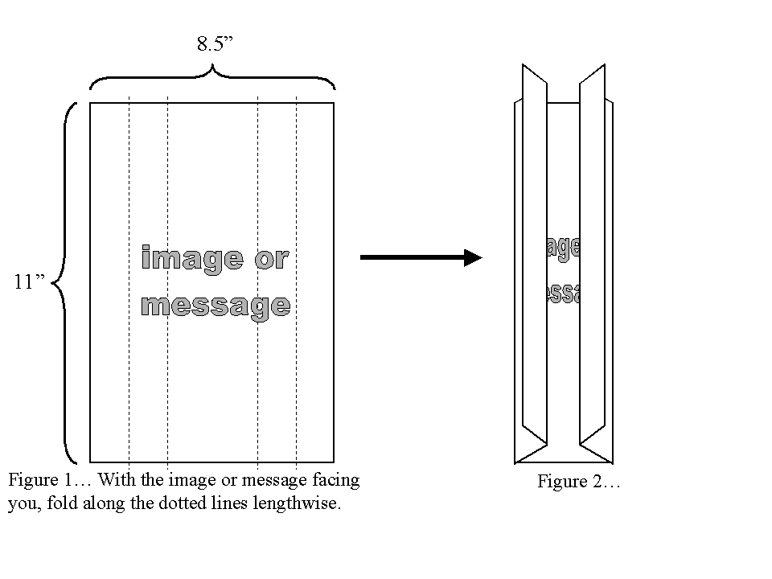 |  | 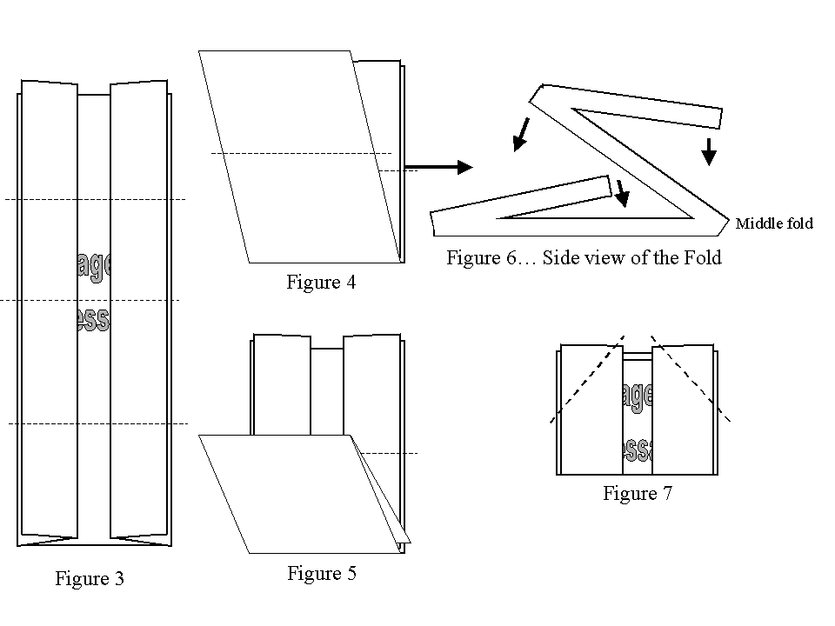
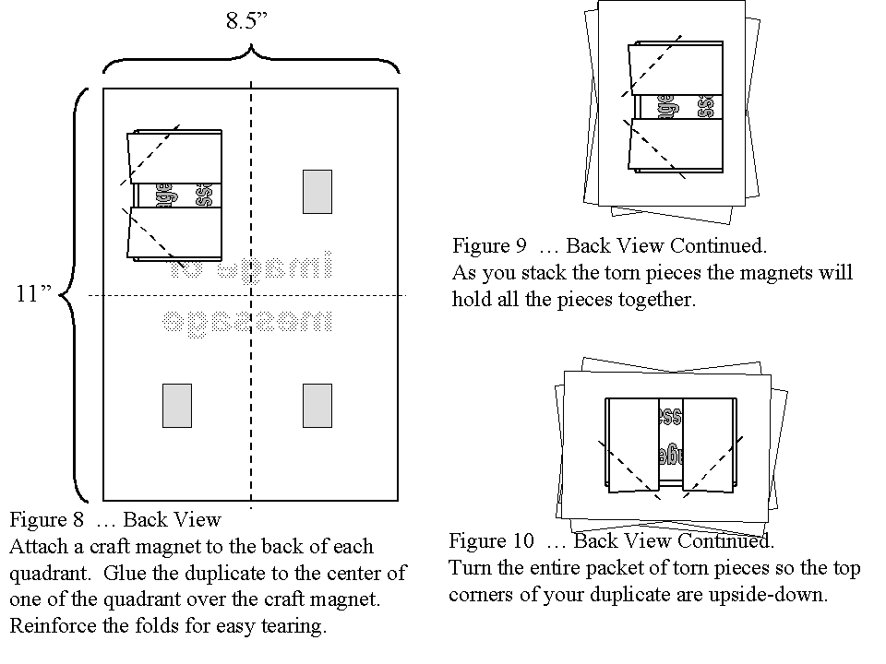 |  |  | 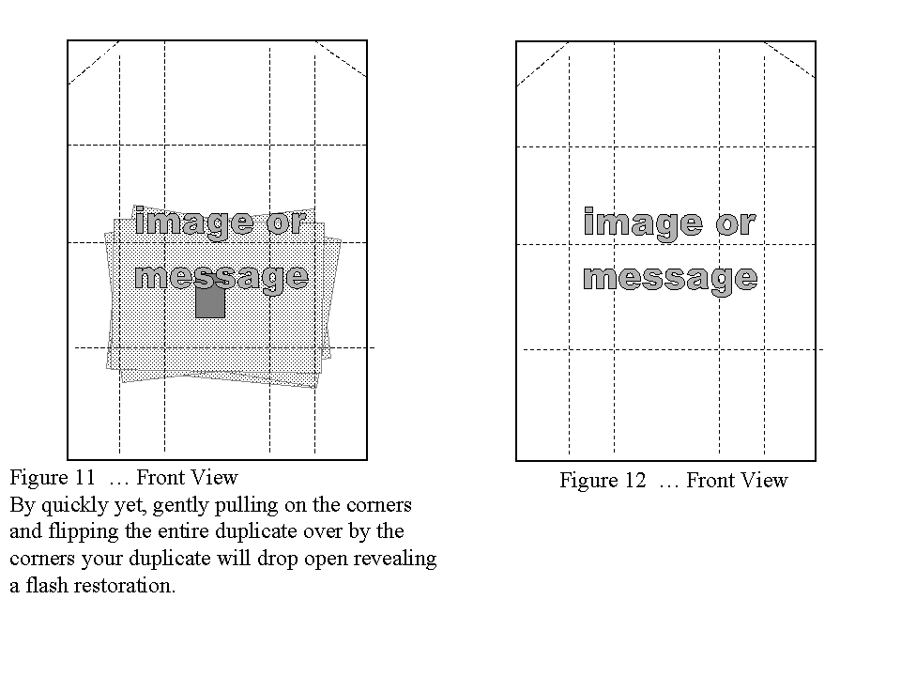

Paper Bag Production

This is an easy to do- easy to make production or change effect that can be used to illustrate many gospel truths. The basic idea is as follows: The performer displays a grocery bag and shows it to be empty. After putting an inflated balloon inside and popping it from the inside and then tearing up the bag, it’s discovered that the bag contains a teddy bear, silk scarves, a Bible, or any other object that needs to be produced or changed.

Needed:
Two paper grocery bags (the kind with flat bottoms), scissors, a balloon and your load (whatever you want to have appear).

Preparation:
Take the first grocery bad and open it so it sits square on the table. Drop your load into the bottom of the bag. Slide the second bag open and inside of the first bag and time off the top of the second bas so it matches the first bag. You now have a bag with a false bottom inside. You may want to fold the edges over several times to hide the fact that you have two bags at work. By tilting the open end toward the audience, you can show the bag completely empty.

Presentation:
Show the bag empty. Inflate a number 9 balloon and drop it into the bag. Grab the balloon from out side the bag and squeeze until the balloon pops. Use a pencil to stick into the bag if that would be easier to pop the balloon.

Now crumple the bag and turn it over and rip open the bottom and produce your load and hold it out for the audience to see. Toss the bag behind the puppet stage or into your box and go on with the performance.

Fold the excess over or trim with a scissors

Your Load

False Bottom
OTHER IDEAS:

- Cut up a rope into smaller pieces and drop into bag and cause a restored one to appear to illustrate the effects of sin and the saving power of Jesus Christ.
- Drop individual silk handkerchiefs of different colors into the bag and cause a larger, multi-colored silk handkerchief appear to illustrate the Trinity, or Romans 8:28, or teamwork.
- Drop one ping pong ball into the bag and tear open the bottom and allow a large load of ping pong balls to drop put onto the floor illustrating God’s blessings, the rewards of tithing or how your life can get out of control.
- Drop a few feathers representing sin into the bag and cause the “sins” to multiply.

“Ring On A Rope”

Needed:
At least a 5" Macramé Ring (found at craft stores and hobby shops)
Soft Magicians Rope or at least a six foot thick, soft shoelace or boot lace.

The diagrams should help you understand how to link the ring onto the rope. The diagrams are shown as if you are holding the rope and looking down at it as you will during the presentation. I usually use two volunteers. One to hold each end of the rope.

Hold the middle of the rope so that the rope is stretched horizontally to the floor. Place the ring so it hangs on the rope. See figure 1. With your free hand, reach down between the doubled ropes; grab the bottom of the ring. See figure 2. Letting go of the rope while pulling the ring up between the ropes will cause the ring and rope to “grab” each other into a knot.

This can also work by having one or two people hold each end of the rope,

“HUNG-UP ON BAD HABITS”
“Some people think that getting involved in bad habits is alright. So, they play around with sin and don’t think much of it.” (Place the ring on the rope).

“They think that as long as they go to church and pray, maybe even read their Bible, that they can quit smoking, drinking, swearing or sinning anytime.” (Begin sliding the ring back and forth on the rope).

“What they don’t realize is that the devil wants to get a foothold on them. Then they’ll be trapped and in trouble.” (Pull the ring up through the ropes and cause the ring and rope to link.)

“Now look. This person is stuck in his sin because he gave the devil a foothold.” (Have both volunteers take on end of the rope together. You take the other end and begin to pull to show that the ring is knotted to the rope).

“But there is hope! We don’t have to stay in our sins! Jesus came that we could get out of the problems we face and the sin we’re stuck in because of bad habits. Let’s pray!”
METHOD ONE
Assistants hold these ends
You hold
this end
Grab the ring here and pull thru the rope
TA – DAAAA!!!
"Ring Off a Rope"
You can be freed from the bonds of sin!

Objects Needed:
At least a 5" Macramé' Ring (found at craft stores and hobby shops) Soft Magicians Rope or at least a six foot thick, soft shoelace or boot lace.
A ~Christ Head Handkerchief (available from Doc Haley Magic) or red handkerchief silk
or cotton.

The diagrams should help you understand how to 'tie" the ring onto the rope. The diagrams will also show you how to unlink the ring from the rope from underneath
the handkerchief.

What the Audience Sees:
The magician uses two volunteers. After the magician loops the ends through and around the ring, he hands each end to his volunteers. The magician covers the ring
with the handkerchief and removes the ring without touching the ends of the rope.

How To Prepare & the Secret:
Have two volunteers hold the rope at the ends so that it is parallel to the floor. You should be behind the rope facing the audience or class. Hold the ring in front of the rope as in figure 1. Have each volunteer hand you his/her end one at a time so that you can loop it through the ring as in figure 2. Give the ends back to the volunteers. Be sure to have them pull the rope so it is tight. Now place a handkerchief over the ring. By putting your palm on top of the covered ring and reaching in front to with your fingertips to grasp the rope. You will be able to squeeze the top of the ring and the middle of the rope together and the ring will automatically loose itself from the rope. See figures 3 and 4.

Central Truth:
You can be freed from the bonds of sin through Jesus Christ!

Presentation:
• Choose two volunteers from the audience or class. Have them hold the rope by the ends parallel to the floor. Make sure the rope is tight and in front of you.

• Talk about sin - it's effects on the life of a person. The Rope represents the person. Hold the ring in front of the rope and talk about sin and how innocent it could be
Figure 1
Figure 2
Figure 3
Figure 4
Begin to loop the ends of the rope through the ring as in figure 2. Give the ends back to your volunteers. Discuss the way that sin will cause us to become wrapped-up in wrongdoing. Expand on the idea that no one in this room can help us with the problem of sin. There is one person who can.

• Display the Christ-head handkerchief or red silk handkerchief. (If you use a red handkerchief, be sure to explain that it stands for the blood that Jesus shed for us). Begin to talk about the work that Christ did on the cross and how this work can help us today as well.

• Cover the ring with the handkerchief so it cannot be seen. Grab the ring and the rope in the center of the ring and squeeze them together. (Do this so it looks natural
- like you’re just reaching out to grab it with an open hand). As you do this, mention that the Word of God describes how God takes our sin and removes them as far as the east is from the west.

• As you say this, slid the ring and handkerchief along the rope from one side to the other. Then talk about how HE remembers them no more.

• As you talk in this manner, remove ring still inside the handkerchief from the rope. Make your closing statements and invitation to salvation.

You may pass the ring and rope for inspection if you choose to do so.

"The Color Changing Liquid"
Jesus Changes Water into wine, The changes in our
Figure 1
lives, or God supplies our needs!

Objects Needed:
An opaque flower vase just like the one pictured below. Food coloring or bright colored
drink mix, Clear pitcher with water in it.

What the Audience Sees:
The magician or teacher shows a vase that is tilted toward the audience so they can see the bottom. A pitcher of is poured into the vase. The contents are then poured back into the pitcher shown to be a different color.

How To Prepare:
The shape of the vase is what keeps the secret hidden. Drop a few drops of food coloring and about a fourth cup of water into the bottom of the vase. (The water keeps the food coloring from drying up). Or use a small packet of colored drink mix and about a fourth cup or water. (The water keeps the final contents with being filled with chunks of the powder- make sure you really mix up the powder and fourth cup or water). You can now tilt the vase at a 9Q0 angle and the bottom half hides the mixture. See figure 2.

Central Truth:
Can be used to illustrated Jesus changing water into wine, the changes that happen in our lives as we follow Jesus or how God supplies our needs.

Presentation:
This is a great way to tell the story of Jesus changing the water into wine. Emphasizing the servants~ obedience or Jesus first miracle. This is also a great way to illustrate the change that takes place in us once we receive Jesus as our savior. Or you can expand on the changes that we go through as we serve Christ.

This effect can also be used to make water or liquid seemingly appear. By tipping it at a 900 angle and showing the vase with the liquid hidden. Tip it back upright and then after misdirecting by talking or teaching for a moment, you suddenly dump the liquid into a pitcher by turning it almost to a full 1800 angle. You can then draw the application of God supplying or needs.

Have fun experimenting!

Your Mixture
Figure 2
This is what the audience sees.
Figure 3
GOD CAN USE YOUR LITTLE
By Jamie Doyle

Genesis 28:22 “…and of all that you give me I will give you a tenth."

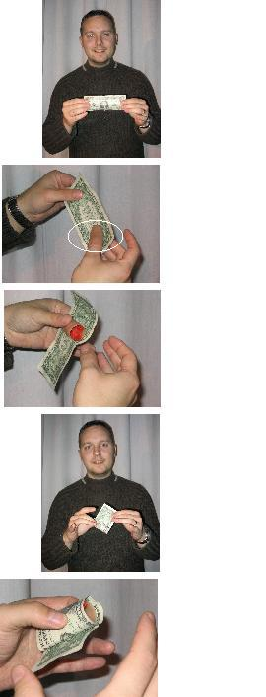
Concept:
Many times children don’t feel that their giving of tithes and offerings can do much because of the very little amount they are able to give. The reality is… God can use what children give Him and he will bless them back for their obedience to His Word.

Effect:
Teacher or performer borrows a One-dollar bill. Showing both sides, the performer proceeds to roll the bill into a tiny tube. As soon as the tube is formed, a long colorful silk streamer is pulled from the tube. The tube is then unrolled and handed back to the spectator it was borrowed from.

Needed:
Thumb-tip.
Borrowed dollar bill
Thumb-tip streamer or a diamond cut silk handkerchief or half of a 15” silk handkerchief split from opposite corners will also do.

Note*With the concept above mentioned, let’s remember that it’s not really the amount you pay for an effect, it’s what you do with it. Sure you can purchase a thumb-tip and thumb-tip streamer usually for under $10. But presenting a well-rehearsed routine with precision and timing, you will have turned this effect into a $100 illusion.

Preparation:
Load the thumb-tip with the silk streamer or split handkerchief. Place the thumb-tip on your thumb. (I usually wear mine on my right thumb – so this is the position I will be describing). Now all that’s left is to borrow a dollar bill from a student or audience member.

Presentation:
Describe how many times children don’t feel that their money can really be used for much. Ask for someone who has a dollar bill to give in the offering. Ask to borrow it.

Once you have the bill, show the it on both sides continuing to expand upon what a dollar bill can buy today that can help the Good News go forth?

Hold the bill as in Photo__. Then grasp the loaded thumbtip from behind the bill as in Photo___.
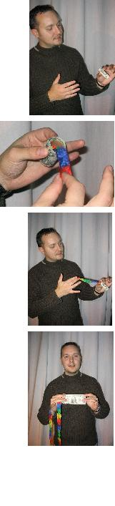
Begin to roll the dollar bill into a small tube as in Photo___. As you roll the bill into the tube, create some misdirection by asking the audience a rhetorical question: “It doesn’t matter the amount that goes into the offering plate, what will really matter is what went into the gift in the first place. Have you ever heard any body say ‘it’s not the gift, it’s the thought that counts’? Well it’s the same with our gifts to God. If we give our very best with the best attitudes going into it, more will come out of the gift in the end.” Then ask the audience to participate by “pulling” good giving attitudes out of the air. “Who has a handful of love? If you do, then toss it into this gift. How about faith in God? If you have an attitude of faith, toss it into this gift. How about obedience? If you are ready to give out of obedience today, toss it up into this gift.” Continue to name attitudes if you please. As you call out each attitude, reach into the air and pretend to grab that attitude and toss it into the tube. As you do this, the audience will catch on and participate.
“As you give with the right attitudes, God will use you gift – no matter how big or small it is to do amazing things.” As you begin to say the following begin to pull a little bit of the streamer out of the dollar at a time. “As you give out of love, the people we are trying to reach will sense God’s love and respond to the gospel message.” (Pull out a little bit of the streamer). “As you give out of faith, you gift will be added to help meet the financial needs to send out the message of the gospel.” (Pull out a little bit more of the streamer). “As you give out of obedience, God will be pleased with you and the attitude of your heart and that’s more important then any sized gift that could ever be given.” (Pull out all of the streamer).

As you unroll the bill place your thumb back into the thumbtip and hand the bill back to the spectator.

Borrowed Ring to Nest of Boxes

Effect
A ring borrowed from a child disappears and is found inside four nested boxes, the last one being padlocked.

Items Needed:
Quarter Go Box
Small Lock And Key
A handkerchief with a ring sewn or glued into its center.
Three gift boxes that nest together – The quarter Go Box, when open, must fit entirely into the smallest of the nested boxes.
A small jewelry box (ring box)

Notes and Set-up
In this version, the boxes are in full view during the entire performance.
There are three wooden boxes in the set, plus the Quarter Go Box. (I have actually used cardboard gift boxes as well). Each of the three boxes has a square hole cut in the back. When nested, the bottom of the holes line up, creating a shelf on which you can balance an open Quarter Go Box. The Quarter Go Box is already padlocked, but the trap is open. Tucked inside the three other boxes, only a small part of the Quarter Go Box protrudes, reducing angle problems. You can easily load the ring into the open Quarter Go Box at the appropriate time, as I'll explain.
The set of boxes, nested inside each other, rests on my table, with the ring box balanced on top. The key to the padlocked Quarter Go Box is already inside of the ring box prior to the program.
You must be able to “hold-out” the ring (Meaning you must be able to hold onto the ring without the audience knowing that you have it.
Performance
"We need to find a reliable person who will let us borrow her ring. How about the young lady right there -- would you please come up?" The girl joins me on stage. Meanwhile, I pick up the gimmicked handkerchief with a ring secretly sewn into the center I display the ring and hold it up high “Today I am going to let this ring represent something of great value. It will represent your life.”
I don’t want anything to happen to your life… for safekeeping, let's wrap the ring in this handkerchief." I hold the ring in my right hand and drape the handkerchief over my hand so the center with the sewn ring – under the cloth – is over the top of my hand. I casually palm or hold the ring loosely in my right hand as I take hold of the sewn-in ring with my left hand through the fabric.
"Here you go, Emma. Hold on to your life. It is very special. I’m sure you want the best for your life.” Through the cloth, the girl is holding what she thinks is her borrowed ring. I encourage her to hold it up high.
I motion over to the table. “Do you know what this is? As I say this, the ring is in my right hand. I move toward the boxes to pick up the ring box with my left hand. As I do this, my right hand goes behind the boxes and drops the ring inside the open Quarter Go Box, which is balanced inside the other three boxes. If I have time, I'll close the Quarter Go Box trap door with my right hand fingers.
If I don't have time, I can close it later with no problem. The main thing is to put the ring in the box. This whole movement of picking up the dental floss and dropping off the ring box takes only a few seconds.

“This ring box is where we would normally keep an expensive ring if we didn’t want anything to happen to it. It will represent our own will and wants. When we are born our life is kept by our own will and wants.”

"Now, Emma, in just a moment, I'm going to snap my fingers. That ring will disappear form the handkerchief, fly through the air, and land inside this box!" As I hold up the small ring box, I am careful not to rattle it around. "Okay, Emma. Do you still have the ring?" she says yes. “Watch! One, two, three!"
I snap my fingers and say, "Emma, did the ring disappear? No? Oh! I forgot to say please!" As I say, please, I snatch the handkerchief out of her hand, shaking it out to show that the ring has vanished. The girl is usually very surprised and looks around on the floor for the vanished ring. Be sure that when snapping the handkerchief away, do not expose the ring to the audience.
"Don't worry, young lady, your ring has landed safely inside this box!" I hold the box up to my ear. I shake it so it rattles around. At this point, people think it's the ring.
I allow the girl to hold the ring box “Do you know what this is?” I way this as I motion to the large box. “This is a big box that represents God’s Will. Do you know what’s inside of this box? Of course not, you haven’t seen the inside. That’s just like God’s Will. It isn’t always easy to know what God has for your life. There’s only one way to know what’s inside of this box… you have to give up your life!” Motion toward the handkerchief. “That’s right, you now must make a decision. Will you keep your life and act selfish, or will you give it up for God’s Will?”
9 out of 10 times the girls will choose to give up the ring.
”Emma, open the box and tell us what you see inside." The girl opens the box and says, "A key." I say, "These kids are so advanced! she's speaking Spanish! 'The ring is aqui,' she says!" Then, in surprise, I see that she has a key.
"A key? Emma! Where's the ring? There's no ring? Well, that's too bad, isn't it. But you know, have certainly had a good attitude about this. Let's give her a round of applause! Well, You did make the right decision even if all you have is a key… do you understand why you have a key?” Allow the girl to respond. “You know, we don’t always understand God’s Will either. But, now let’s look at what you gave up your life for.”
I step over to the table and pick up the Nest of Boxes. If I haven't already shut the trap, I do that now, and with my thumb, push the Quarter Go Box into the Nest of Boxes, unknown to the audience.
As I say this, I set the boxes back on the table and begin opening them. Opening the big box, I lift out the medium box and set it on the top of the big box. Then the small box, stacking it on top of the middle one. "I don’t think the ceiling is high enough!”
"Inside this box is another box, and it's padlocked" Emma, do you have any idea how we can get into this box? The key? That's a great idea!" If the girl is old enough to handle this, I let her unlock the box. Otherwise, I unlock it, lift the hasp, and hand it to her to open.
"Emma, what do you find inside the locked box? A ring? Is that your ring?" The girl holds up the ring and the audience applauds.

“Boys and girls, outside of God’s Will we would lose everything. When we are willing to give up our lives for God’s Will, He will give us back our lives so we can please Him.”

*The routine is an infusion of Samuel Patrick Smith’s routine and Duane Laflin’s routine with a few embellishments of my own.

Going Through Tough Changes
By Jamie Doyle

These have come so that your faith--of greater worth than gold, which perishes even though refined by fire--may be proved genuine and may result in praise, glory and honor when Jesus Christ is revealed. 1 Peter 1:7

Concept:
Going through changes and trials are sometimes tough. But God knows that it's for the best. And there will always be a positive end result.
Items Needed:
- Full Sheet of Flash Paper
- Lighter or Flash Igniter
- Plain, white, photo-copy paper
- Thick, black marker
- A table to place all of the items
- A box or place to hide the items prior to the lesson and after the lesson

The Effect:
A note is shown with a message written on it. It is crumpled into a ball, ignited and tossed into the air creating a ball of fire. It then lands on the floor unharmed and opened to reveal a new message.

Preparation:
On the white photocopy paper, write the words "God is Always Changing Me for the Best!" On the Flash Paper write the words "New Christian!" Crumple the white photocopy paper into a small ball and hide it in your palm so no one else can see it.

The Lesson:
- "Sometimes a new Christian comes along and they don't know that there needs to be more changes in their life to be pleasing to God."

- Show the message on the flash paper.

- "We need to continue to change and grow in God so that others can see Jesus in us and so we can withstand the difficult times that are ahead for us."

- As you say the next line, begin to crumple the flash paper around the ball of paper already in your hand by keeping your palm towards yourself (away from the audience).

- "There will be tough times. Sometimes being a Christian isn't easy. Sometimes it will hurt and it will feel like you are under a lot of pressure.

- As you say the next line, light the ball of paper and toss it into the air above you or high above the heads of your audience.

- "God will make sure that you are changing so you can overcome these difficult times and all you have to do is ask him to help you."

- After the ball has landed, ask the audience member who has it to bring it to you. If you caught it or let it fall to the floor near you, pick it up. Open the crumpled ball to show the message "God is Always Changing Me for the Best!"

- Pray and ask those to respond that need help with changing with God's help.

ANOTHER IDEA
This is another effect that you can use Sparkle Additive by sprinkling some on the flash paper prior to the presentation.

ELIJAH!
1st Kings 18:16 - 39

Concept:
God proved Himself miraculously to all the people in the story of Elijah and the prophets of Baal.

Items Needed:
- Potassium Permanganate (Available at most home improvement centers where water softener supplies are sold).
- Glycerin (Available at most pharmacies)
- Half pages of flash paper, or small balls of flash cotton.
- Crayola Markers, (Or a dye method mentioned earlier in the book).
- Cookie sheet, hot pads and a small paper cup.

The Effect:
As the teacher or performer tells the story of Elijah and the Prophets of Baal, He builds a small replica of the altar that Elijah might have used. After quoting the prayer that Elijah prayed, the small replica seems to “Spontaneously Combust” (In other words, it starts itself on fire.

Preparation:
This will take some practice in timing. Make sure you are in a well-ventilated area. The reaction of the glycerin and Potassium Permanganate will produce a very hot flame. The following should be done well before you present it.

- Place hot pads on your presentation table so that the cookie sheet does not touch the table.

- Dye 6 entire sheets of flash paper the color grey and allow them to dry completely. – or – Dye six small balls of flash cotton grey and allow them to completely dry. Once dry, tear or cut each in half and crumple each into a small ball. These will be your 12 “stones” for the altar. Dye a few pieces completely brown. Once dry roll them up tightly. These will be your pieces of wood. Make sure one is longer then the others. Dye one piece completely brown and twist it into the shape of a bull, cut into the shape of a bull or crumple it up and tell the kids that it is a piece of the bull.

- On the cookie sheet place about two tablespoons of the Potassium Permanganate crystals in small mound. The kids will not be aware of this small mound. Use the spoon to make an indent in to the small mound. This is where you will put the glycerin later. **DO NOT put the glycerin on the mound yet… it will catch fire!

- In the small paper cup put about two teaspoons of glycerin. Place this away from your presentation table and hidden.

- Put the “stones” and “wood” in front of the mound or crystals and you’re ready to tell the story.

Ham it up a little, dress up as Elijah or have someone else dress up and act it out as you tell the story.

The Lesson:
- Begin to tell the story of Elijah and the Prophets of Baal. Tell it all the way to the point of the prophets praying and shouting with no response.

- Then explain that it was Elijah’s turn. Tell the kids that you would like to rebuild that scenario by showing them what it might have been like. However, you could not afford to mess up the church the way the Bible records Elijah’s sacrifice.

- Arrange the “stones” completely around the mound of crystals – starting with the ones in front first. This will help conceal the mound of crystals. As you arrange the stones, explain what you are doing to the kids. Tell them that Elijah had to repair the altar and he placed twelve stones around it.

- Place the “wood” propped up along the sides of the mound make sure that the longer one is in place to catch some of the flame and that the other end is laying on one of the “stones”. This will ensure that the “stones” burn up as well.

- Place the “bull” on top of the mound but not so that it’s blocking the indent for the glycerin. Explain the Elijah prepared the sacrifice the right way.

- Then tell the kids about having the trench dug around the altar and 12 huge buckets of water being dumped into the trenches and all over the altar. Explain that this is the part that would have made a really big mess. So, instead, you brought only one cup, and it will have to represent 12 huge buckets of water. Dump the glycerin into the indent and step away to the side.

- Then explain that Elijah prayed a simple prayer: "O LORD, God of Abraham, Isaac and Israel, let it be known today that you are God in Israel and that I am your servant and have done all these things at your command. Answer me, O LORD, answer me, so these people will know that you, O LORD, are God, and that you are turning their hearts back again." (1st Kings 18: 36-37)

- Expound on the fact that Elijah’s prayer was simple and that Elijah demonstrated simple faith in God. As you expound on these things allow the smoke rising from your altar to interrupt you. Most of the kids will be shouting and pointing by this time. The smoke will erupt into a large flame – igniting the flash paper and in a few seconds you will have a huge flash of fire and some cool puffs of smoke.

- Close the illustrative sermon by explaining that the sacrifice, the water, the wood and even the rocks were burned up by God’s powerful answer.

Another Idea:
Flash String (a commercial item sold in magic stores - can be used instead of the chemicals). Prepare as instructed above. Place the flash string in the middle of the “Altar” space (This should be done ahead of time). Have an end hanging down below just beyond the edge of the cookie sheet. Have a kitchen lighter next to it on the table. When the time comes, use the lighter to ignite the sting. This will act as a “wick” to ignite the flash paper and flash cotton. Special note: the flash string could also be dyed a dark grey… see the section on adding color to your flashy lessons.

Jamie Doyle

Jamie Doyle is an exciting young man who has over 10 years of experience as a Children’s Pastor, evangelist, conference speaker and children’s entertainer. He and his wife, Jennifer, continue to disciple and pastor all ages to effectively reach children. Every Sunday the Doyle’s develop and present unique and relevant object lessons, stories and illustrative sermons to effectively teach children the Word of God. This includes lessons that use simple pyrotechnics and chemicals.

Other Books by the Author:

- TEACHING KIDS TO GIVE
- ADDING FLASH TO YOU LESSONS

THE FINE ART OF SYNERGY
- FUN WITH BALLOONS – Lecture Notes
- MAGIC WITH A MESSAGE – Lecture Notes
- IT’S BASICALLY PUPPETS
- INCREDIBLE OBJECT LESSONS
- MORE INCREDIBLE OBJECT LESSONS

You may contact the Author at:

Jamie Doyle Ministries

address: 14898 Energy Way Suite 200 Apple Valley, MN 55124
phone: 952.997.2222

email: Jamie@JamieDoyle.com
internet: www.JamieDoyle.com

